**Project Overview**Description

The three-tier database application we will be building is a library management system. The system will perform all fundamental features that a library will need in daily operation. These actions include operations such as issuing library cards, searching for books, checking books in and out, and placing holds. It will also include extra privileges for library staff, such as managing accounts, adding and removing books, and paying fines. The organization that oversees the library will be able to request general analytics and telemetry from the librarians. We as the developers will be designing and implementing the project, making sure all development goals are met. The system will be a web-accessible login-based application and maintain a user interface that is clean, clear, and informative so that all of the various users can navigate the application with ease.

**System Environment** (Nicholas)

Structure of the system

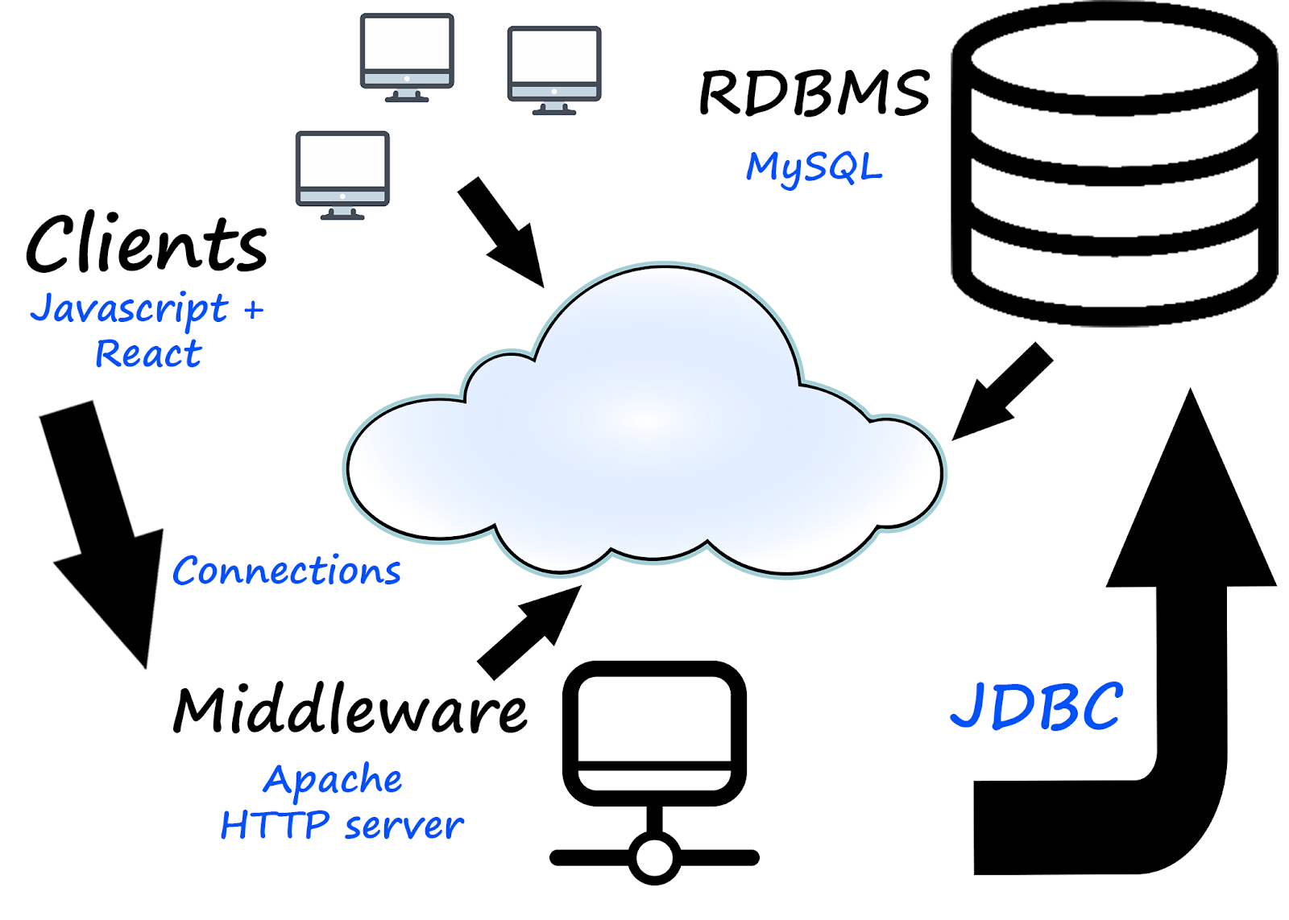

Software used

* Apache HTTP Server

RDBMS

* MySQL

Application Languages

* Java, HTML, CSS, Javascript, React.js. JDBC

Describe each individual function, functional process and I/O:

View late fees

* While looking at account details, library users can clearly see any outstanding fines they need to pay
* System will display current fines and when clicked, will provide additional information regarding what incurred the fine

View due date of items

* While viewing their account, users can click to see their checkout history displayed as a list
* Currently checked out books will show their check-out date

Generate analytic report

* Library staff can generate a detailed report to see analytic data the system collects about the library
* The report will show for a given month or calendar year:
  + The amount of check-ins and check-outs for books
  + The current amount of each book in stock and checked out, and missing
  + Total fines owed to the library

Login/Logout

* The user will be able to log in and out from any computer
* Users can then view any account information from there
* Users can reset their passwords using the provided email address